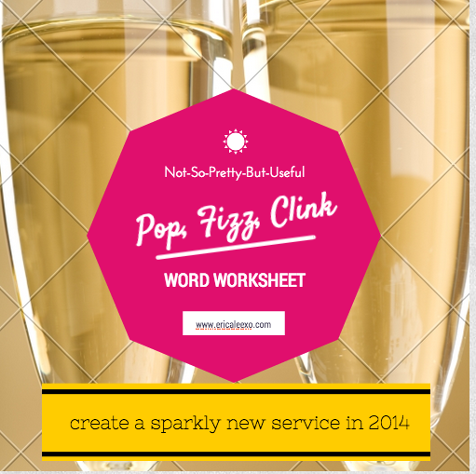

THE BASICS //

1. What do you do?

2. Who do you do it for?

3. Why do you do it?

4. What is the ONE BIG PROBLEM you want to solve in your clients lives with this offering? Every offering must solve a CLEAR, SPECIFIC problem.

THE BENEFITS //
1. What are your clients experiencing in their lives right now? What do their lives look like when they come to you for help?
Example. If you’re a health coach, maybe your clients bodies embarrass them because their clothes totally hug all the wrong places. Maybe they’re totally wiped out all the time because they're so out of shape every movement takes a ton of effort. List at least 3 examples.

Write about your clients’ current experience here:

2. What kind of experience do you want your clients to have while working with you? What FEELINGS will you give them during your time together?

Write about how your client will feel when knee-deep in work with you:

3. Ask yourself what your client’s life will look like AFTER working with you. How will they be changed? How will they be closer to their ideal lifestyle? (These are the BENEFITS of your offering!)
Example: If you're a health coach, you're not selling nutrition advice. You're selling body confidence and the ability to finally zip your damn skinny jeans. Get specific as humanly possible. Words like "clarity" and "happiness" are BANNED. BANNED, I SAY.

Sometimes people get confused about the difference between features and benefits. Here’s a handy dandy chart below to help you decipher between the two!
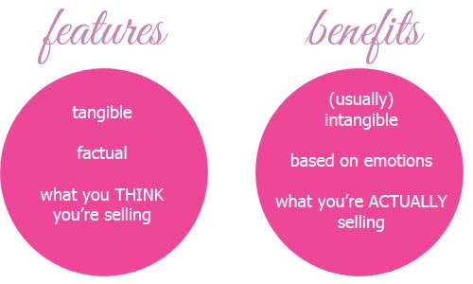

4. Your job is to take your clients from where they are now, to where they want to be. What would need to happen, change or shift in your clients’ lives for them to travel from number 1 (where they are now) to number 2 (where they want to be)?

Write about the transformation your client would need to go through:
How long will it take?
What support will they need?
What do they need to learn/do/experience?

5. Now, let’s talk logistics. Here, list the process your client will take from beginning to end to achieve the transformation they desire. Really step into their shoes.
Example: If you’re an online entrepreneur, chances are you’ve purchased a service from someone else, so you know what the process is like. So for example, if you listed "private coaching session" above, what would that look like? Would you need an intake form first? And then an interview? And then a wrap-up email?

Here’s the process for my Overnight Celebrity service.
- Client books freebie appointment via ScheduleOnce
- I call client at scheduled time via Skype (and using E-camm to record our conversation)
- I create an official proposal for the client. Client okays it.
- I send the client a first invoice, contract & playsheets.
- When client pays the invoice & signs the contract, I officially add them to my calendar & send them a link to schedule their copy clarity session.
- Client schedules copy clarity session and works on playsheets.
- Client sends playsheets to me at least 24 hours before our session.
- We hop on Skype at our scheduled time (again, recorded) and I do my thang.
- I write. Client relaxes. I deliver drafts in 72 hours.
- I send through drafts. Client gives feedback within 48 hours.
- I send second drafts. Client gives feedback within 48 hours.
- I wrap up and deliver final copy plus my wrap kit to client.
- Final invoice is sent.
- Follow-up is sent one week, one month & three months after work together. I use Google Calendar to set reminders.

And there you have it!

List the steps of your process here (and please don’t stress about this – it WILL change over time!):

YOUR WORK STYLE //

1. Let’s take the focus off the client & onto you. No matter what your client wants or needs, you won’t be able to deliver maximum results unless you’re doing your job in a way that’s in alignment with your natural abilities and gifts.

Remember: This is YOUR business and you can work any way that feels good to you.

So… how do you like to work?
Consider…
Do you like to work one-on-one? (This is where I suggest most people start!)
Do you like to work with multiple people at once?
Do you like short, intense bursts of work (i.e. could you spend an entire day w/ one client, and that's it) or would you rather set up long-term relationships?

Write about how you like to work here:

THE SECRETS OF SEDUCTIVE SERVICES //
Now that you’ve got the basics down, you’ve got to find a way to make sure your offering really stands out. How can do you do that? Here are just a few ways to create an offering nobody can say no to:

UNIQUE TURNAROUND: Can you offer a speedier service than the competition? Maybe you offer lightning-quick turnaround on your web design services while your clients take months to complete one project. Maybe your coaching clients see rapid-fire results in less than 60 minutes while most coaches require a 3-month commitment. Get creative! (Just make sure you’re not promising something you can’t deliver!)

UNIQUE DELIVERY METHOD: Think about the way most people deliver content in your niche. For example, most life coaches do live coaching calls. If you’re a coach, can you come up with a Recorded messages? Customized videos? Skype Instant Messaging Sessions for the shy types?

Basically, people LOVE novelty. Forget all the “rules” + come up with some ways you can turn your service into a one-of-a-kind experience for your clients.

Brainstorm some creative (and seductive) tweaks you can make to your offering:

DRESS UP YOUR OFFERING WITH BONUSES //

If your service seems too large or too small, bonuses are the perfect way to balance things out. If you’re giving too much away, pull out one of your core components and list it as a bonus instead (you can even list it as a limited time bonus – like only the first 10 sign ups get this particular bonus). If you DON’T have enough, tack on a bonus that’s easy for you to manage (i.e. an ebook, an old program you’ve retired but is relevant, etc.) Everybody loves a good bonus!

List 3-5 bonus ideas here:
1.
2.
3.
4.
5.

PUT IT ALL TOGETHER //
Here’s something you may not know: Writing your sales page first is actually a great way to create a new service. Crafting copy first helps you define + refine your offering in a way nothing else can.

You've brainstormed quite a bit of goodness. All you need to do now is put together your sales page to see where there are holes. Yep. Writing the sales page for your offering is by far the greatest (& easiest) way to fine-tune your service. And you can quote me on that.

NOW WHAT? //
Congratulations! You’ve set a fabulous foundation for your sparkly new service, but you may be wondering WTF do I do with it?

Well, how does getting your entire sales page written and designed for you in one fell swoop sound? Well, you're in luck! I've teamed up with interior-turned-web-designer Kelsey Grauke to offer a one-stop sales page shop where you can get your landing page copy written written (by moi) and beautifully designed (by Kels) at an exclusive rate. Wanna get in on this much-needed package before we announce it to the masses? E-mail erica@ericaleexo.com and mention the sales page promo to learn more!

BONUS! //
My Tools of Choice for Sparkly Services

1 Scheduling Tool: ScheduleOnce
2. Calendar Tool: Google Calendar (it’s FREE!)
3. Intake Tools: WuFoo.com (FREE or Paid Versions) or Google Forms (FREE) or TypeForm (FREE)
4. Mailing List Management: MailChimp
5. Teleconference and webinars: Instant Teleseminar
6. Live webcasts: Spreecast

ABOUT THE AUTHOR //

I’m Erica Lee Strauss, pixie-sized copywriter, word weaver & marketing maven. I help women entrepreneurs craft conversational copy that sells. I want to live in a world where women rule, people aren’t afraid to say “I love you” and sequins can be worn year-round, without question.

When I’m not working out, downward dogging on my yoga mat and tinkering away on my MacBook, you can find me laughing with friends in the sunshine, sipping chai tea or ferociously writing in my journal. Or shopping.

Wanna know what haute copy can do for you? Check out my couture copywriting services and let me help you land more dream clients in a jiffy.

